|  |
| --- |
| *CometBites* |
| **Design Document** |
| **SE 6387 Advanced Software Engineering Project**  **R.Z. Wenkstern**    ***11/14/2016*** |

|  |
| --- |
| **Group *CometBites*** |
| **Ronaldo Goncalves Junior**  **rxp152830** |
| **Twinkle Sharma**  **txs151730** |
| **Keerthi Santhalingam**  **kxs142830** |
| **Ramakrishnan Sathyavageeswaran**  **rxs142530** |

# **1. Interaction Diagrams**

## 1.1 Place Order

This section presents all interaction diagrams for the UC1 Place Order. Since the diagram contains too much information, the following sections are organized as follows: the black box SSD shown in Figure 1 is subdivided into four parts. Each part highlights the operations which are shown in the subsequent white box sequence diagram.

***ssd_uc1***

**Figure 1: Black box system sequence diagram for Place Order.**

### 1.1.1 StartOrder and selectFoodJoint



**Figure 2: Black box for startOrder and selectFoodJoint.**



**Figure 3: White box for startOrder and selectFoodJoint.**

### 1.1.2 SelectItem and informQuantity



**Figure 4: Black box for selectItem and informQuantity.**



**Figure 5: White box for selectItem and informQuantity.**

### 1.1.3 ViewOrder and checkout



**Figure 6: Black box for viewOrder and checkout.**



**Figure 7: White box for viewOrder and checkout.**

### 1.1.4 MakePayment



**Figure 8: Black box for makePayment.**



**Figure 9: White box for makePayment.**

## 1.2 Extensions + Remaining UCs

### 1.2.1 Maintain Information



**Figure 10: White box for Maintain Information.**

### 1.2.2 Cancel Order

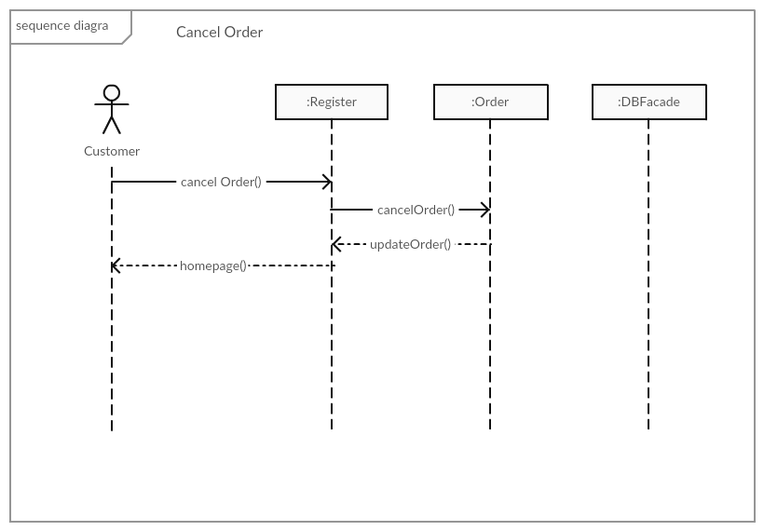

### 1.2.3 Prepare Order

B

### 1.2.4 Place Order through Kiosk

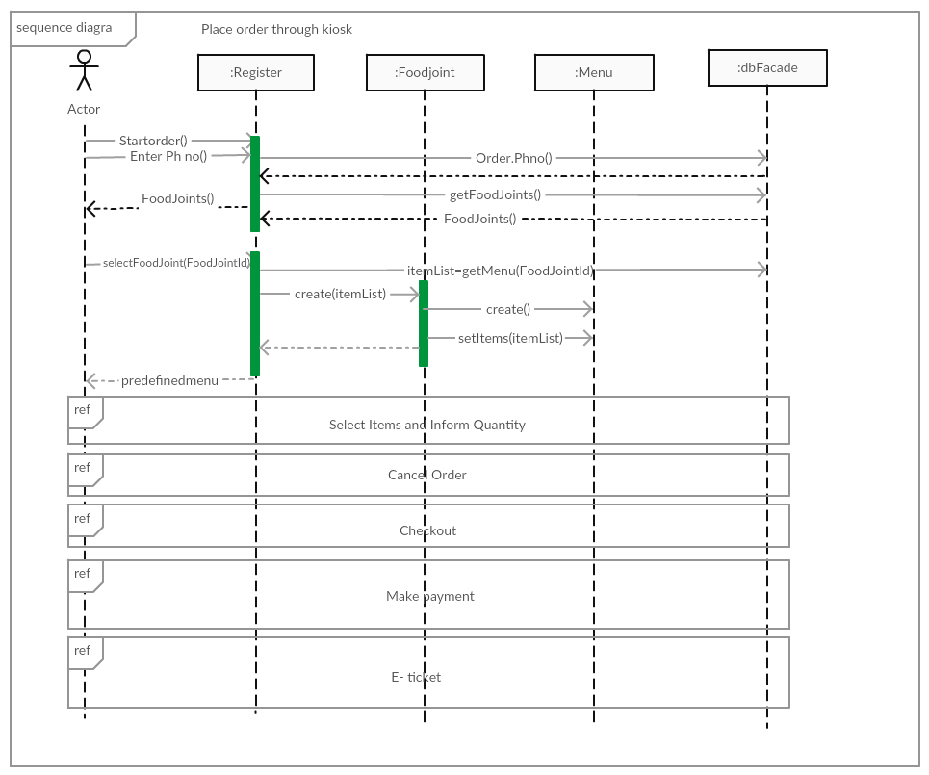

### 1.2.5 Select Items and Inform Quantity

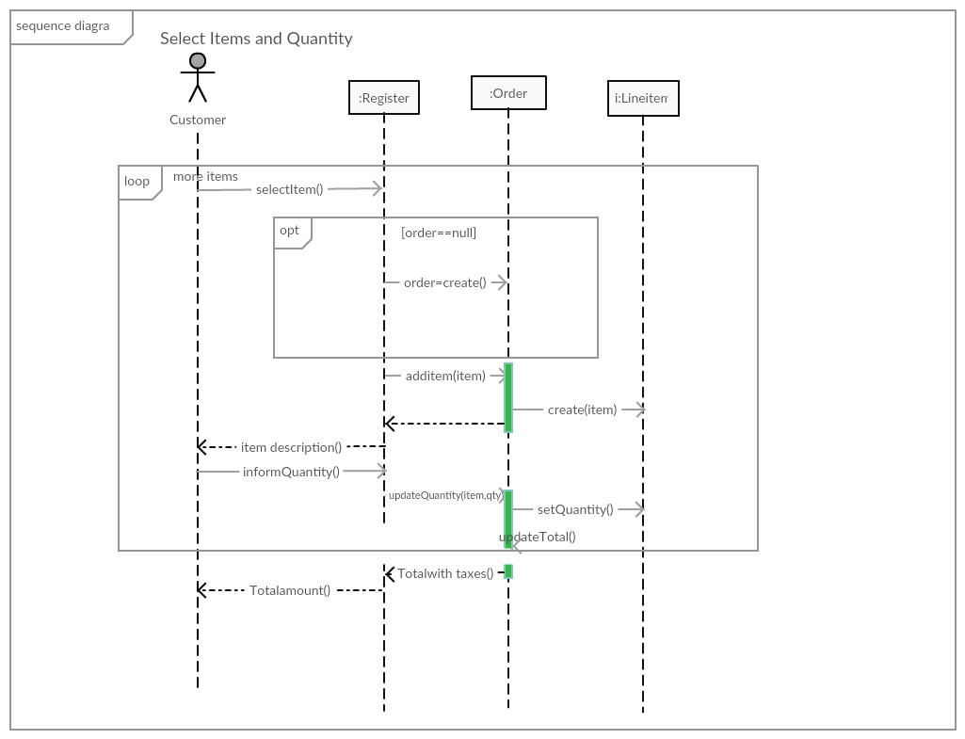

### 1.2.6 Checkout

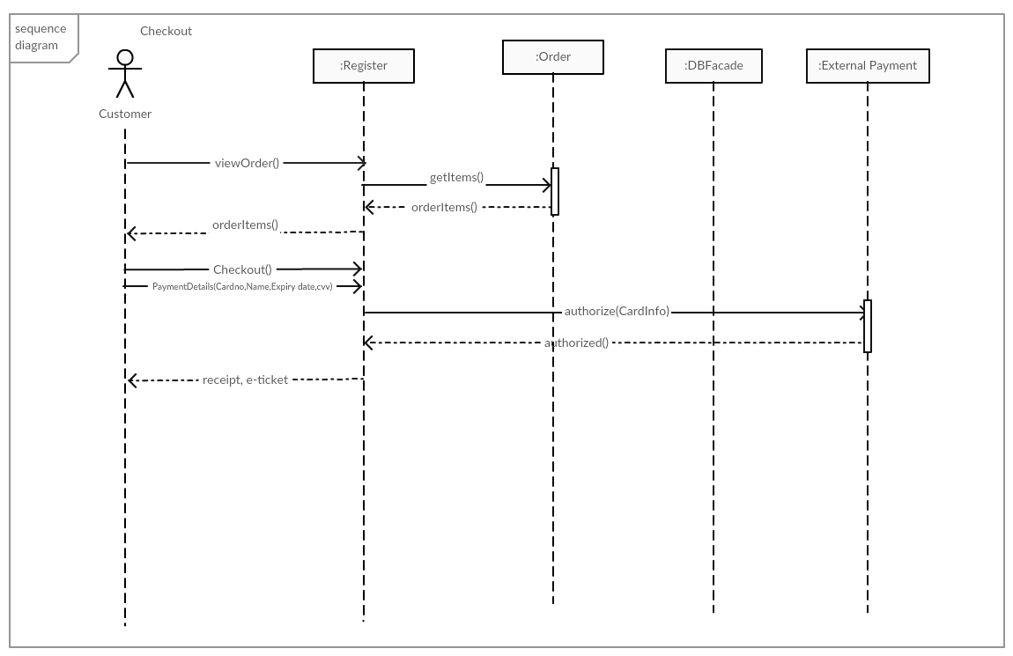

### 1.2.7 Make Payment

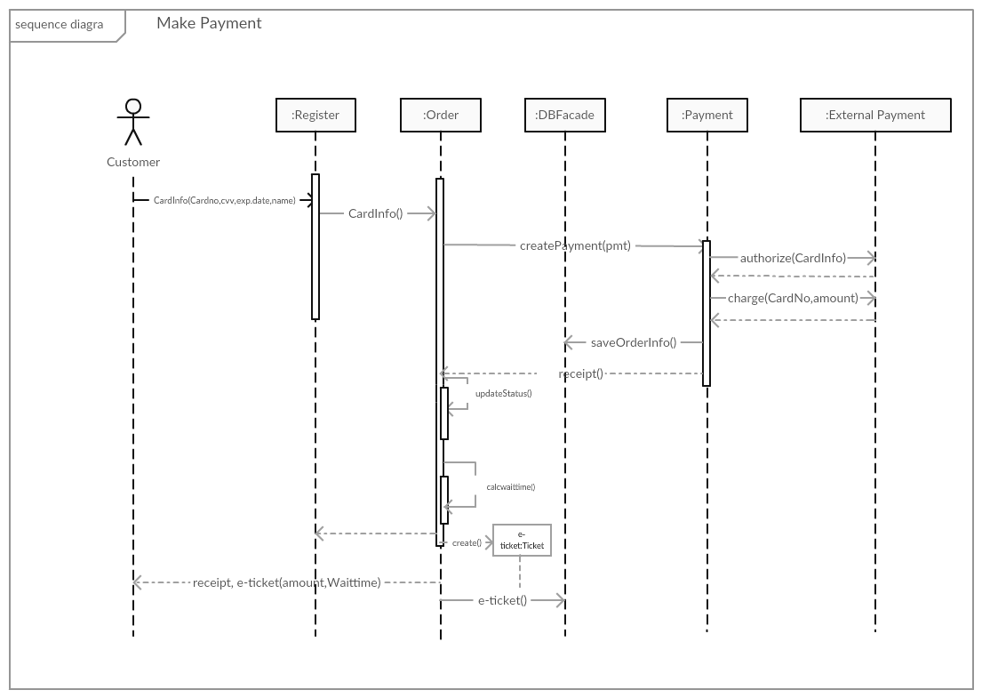

# 2. Design Class Diagram

